Creating Self-Authorship in Advising Interactions with ‘Drifting’ Students
Presented by Megan Schaefer, Academic Success Coach, UNL

Self-Authorship is moving from an external definition to an internal definition of belief system, identity, and relationships. It includes three dimensions and four phases (Baxter Magolda, 2001).

Increased self-authorship is beneficial in advising relationships because it helps students increase their use of critical thinking to make choices, choose appropriate majors, and develop healthier relationships with diverse others (Pizzolato, 2008).
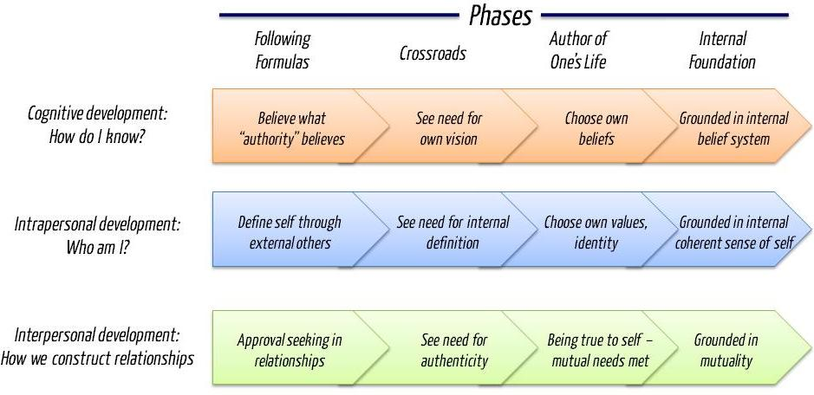

Boe, J. (2011, April 28). Who are you? Self-authorship defined [Web log comment]. Retrieved from: https://imjoeboe.wordpress.com/2011/04/28/self-authorship/

Learning Partnerships Model (LPM) is a way to promote self-authorship by helping students listen to, and use, their internal voice (Baxter Magolda & King, 2004). LPM is like a two-seat bicycle. We as advisors are on the seat behind the student, supporting movement forward, helping the balance, but not in charge of the destination.

Three Assumptions to help students challenge their dependence on authority
- Knowledge is complex and socially constructed
- An internal sense of self is central to knowledge construction
- Expertise and authority are shared in the mutual construction of knowledge

Three Principles to foster self-authorship
- Validate learners as knowers
- Situate learning in learners’ experience
- Define learning as mutually constructing meaning

Validate learners as knowers
HOW? EXAMPLES

Situate learning in learners’ experience
HOW? EXAMPLES

Define learning as mutually constructing meaning
HOW? EXAMPLES

Taking your learning with you:
- What are you already doing to promote self-authorship?

- What is one thing you want to start doing?

- How will you implement this item and why?

References

Baxter Magolda, M. (2001). Making their own way: Narratives for transforming higher education to promote self-development. Sterling, VA: Stylus Publishing.
Baxter Magolda, M. B., & King, P. M. (2004). Learning partnerships: Theory and models of practice to educate for self-authorship. Sterling, VA: Stylus.
Boe, J. (2011, April 28). Who are you? Self-authorship defined [Web log comment]. Retrieved from: https://imjoeboe.wordpress.com/2011/04/28/self-authorship/
Davidson, D. L. (2011). Teacher Tip #2: Self-Authorship & the Learning Partnerships Model. Teaching & Learning Enhancement Center Teaching Tips. Bloomsburg, PA: Bloomsburg University.
Pizzolato, J. E. (2006). Complex partnerships: Self-authorship and provocative academic advising practices. NACADA Journal, 26(1), 32-45.
Pizzolato, J. E. (2008). Advisor, teacher, partner: Using the learning partnerships model to reshape academic advising. About Campus, 13(1), 18-25. doi:10.1002/abc.243

